YEAR 3 ~ CLASS NOVEL RECOMMENDS 2022 - 2023
 | AUTUMN | SPRING | SUMMER
 | THE BLUE ABYSS  https://maestro.cornerstoneseducation.co.uk/project/blue-abyss?group_by=stage&tab= | MISTY MOUNTAIN, WINDING RIVER  https://maestro.cornerstoneseducation.co.uk/project/misty-mountain-winding-river?group_by=stage&tab=introductory-knowledge&curriculumId=4571 | OFF WITH HER HEAD!  https://maestro.cornerstoneseducation.co.uk/project/off-with-her-head?group_by=stage&tab=book-list&curriculumId=4571
NOVEL CHOICE | 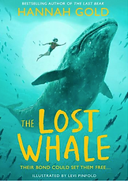 | 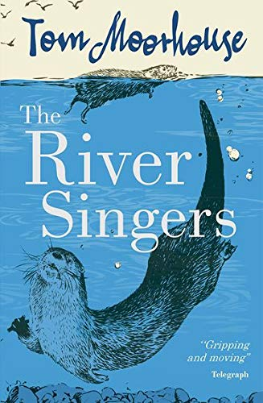
CORNERSTONE RECOMMENDED FICTION | Treasure Island ~ Robert Louis Stephenson  20,000 Leagues Under the Sea ~ Jules Verne  Manfish: A Story of Jacques Cousteau | King of the Cloud Forest ~ Michael Morpurgo  Swallows and Amazons ~ Arthur Ransome  The Hobbit ~ J.RR Tolkien | Treason ~ Berlie Doherty
CORNERSTONE RECOMMENDED NON FICTION | Cephalox: The Cyber Squid (Sea Quest)  Sharks: Facts at your fingertips (DK Pocket Eyewitness)  Pirates 'n' Pistols: Ten Swashbuckling Pirate Tales  Under the Sea (Usborne Picture Storybooks)  Dougal's Deep-Sea Diary  Submarines (Usborne Beginners Plus Series)  Ocean (DK Eyewitness)  Weird Sea Creatures  Oceans: Dolphins, sharks, penguins and more! (National Geographic Kids)  See under the Sea (An Usborne Flap Book)  Secrets of the Sea: Discover a Hidden World (Big Picture Press)  Under Earth, Under Water  Ocean: a children's encyclopaedia  Into the Abyss (Tom Swift, young inventor)  The Deep-Sea Floor | Rivers and Mountains (Physical and Human Geography) Rivers Around The World (Geography Now) Rivers: The Study Book (Discover & Learn) Rivers (Where on Earth?) Raging Rivers (Horrible Geography) Rivers of the World (Great Rivers) A Drop in the Ocean: The Story of Water (Science Works) The Water Cycle (Geographics) The Water Cycle (Collins Big Cat) Mountains (Go Facts: Natural Environments) Mountains (Geographics) Mountains (Explorer Travel Guides) How to Survive on a Mountain (Tough Guides) Freaky Peaks (Horrible Geography) Rivers (Habitat Survival) Mountains (Habitat Survival) Pollution (Ecographics) | Terrible Tudors (Horrible Histories)  Tudors and Stuarts (Usborne History of Britain)  Men, Women and Childen in Tudor Times Elizabeth I (Discover the Tudors) Everyday Life (Discover the Tudors) Tudors and Stuarts in Britain (Tracking Down) Tudor Exploration (Discover the Tudors) Royals, Rebels and Horrible Headchoppers
OTHER | https://www.booksfortopics.com/oceans-and-seas | https://www.booksfortopics.com/mountains-and-volcanoes  https://www.booksfortopics.com/water | https://www.booksfortopics.com/tudors

