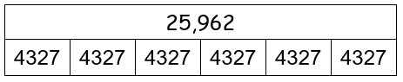
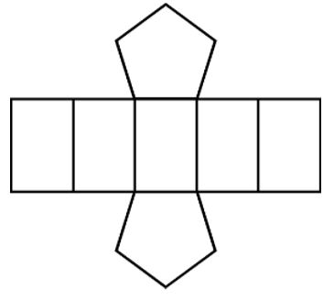
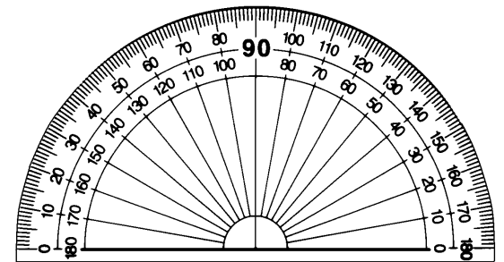
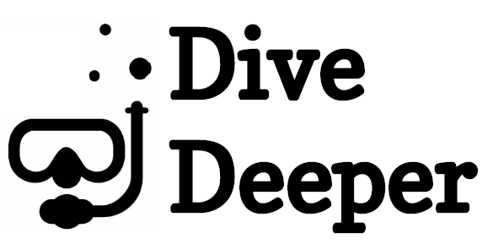

+
Year 5 Examples

23,628 lies somewhere between 23,600 and 23,700. It is 28 away from 23,600 but 72 away from 23,700.
Therefore it is nearer to 23,600.

Round 23,628 to the hundred.

Prove it

Amy uses two-thirds of a can of paint on Monday and one-sixth on Tuesday. She uses five-sixths of the can altogether.
1
6
2
3
Maths story
A common mistake might be to record the angle as measuring 45º. This mistake is easily made because the inside set of numbers has been read rather than following the numbers from 0 to where the angle finishes.
This must be the net of a pentagonal prism because it has 2 faces that are pentagons and are opposite each other. There are also 5 faces that are all rectangles and will connect to each of the sides of the pentagonal faces.
Make a mistake

Explain it

4327 X 6

Draw it

