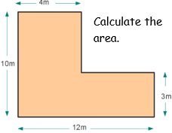
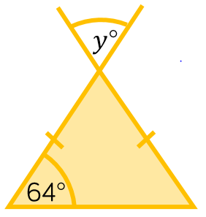


Year 6 Examples

4378 ÷ 28 = 156 r10
The inverse of division is multiplication.
So 156 X 28 = 4368
4368 + 10 = 4378

4378 ÷ 28

Prove it
1
6

Three friends each had a third of the half of a cake left over from a party. They each had .
X
1
2
1
3
Maths story
A common mistake might be to calculate (4 X 10) + (3 X 12). This mistake is easily made because the available lengths have been multiplied rather than splitting the composite shape into 2 rectangles and finding the length, e.g. 12 – 4 = 8.
This is an isosceles triangle so there is another 64º angle. Angles in a triangle total 180º, so to calculate the third angle, you find 180 – (64 + 64) = 52º.
Vertically opposite angles are equal so
y must also be 52º.
Make a mistake

Explain it

If 24 is 10% of a number, what is the original number?
10%

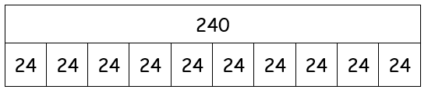

Draw it

