It has been great having your students join CEET this Summer term. They have taken part in lots of activities to help support their self-esteem, communication and team work, individual skills and exploring new places in North Devon. They also developed their understanding of community and the importance to help others in their community, learn about their community and about a variety of community projects which they can get involved in. This term’s activities:
- Learning about shark and rays in North Devon
- Beach cleaning and litter picking
- Beach and Nature art
- Team games
- Butterfly surveys and wildlife scavenger hunts
- Stand Up Paddle Boarding
- Gardening and planting
- Clay/ pottery
- Yoga
- Problem solving activities
- Building community storage sheds
The students took part in team activities as well as individual activities.
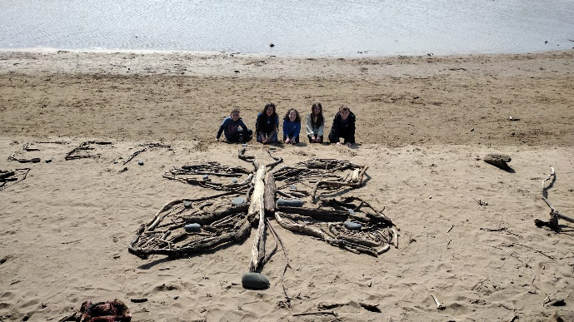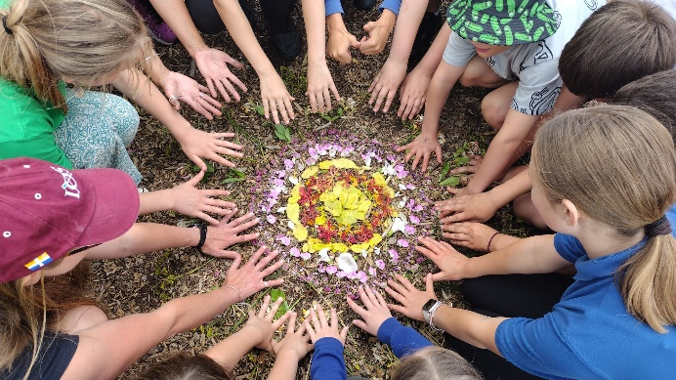
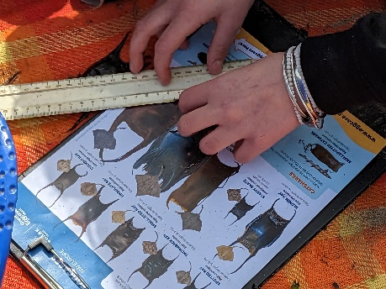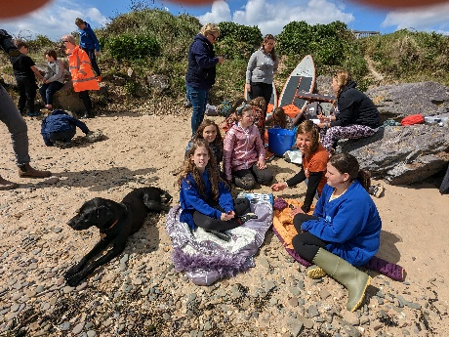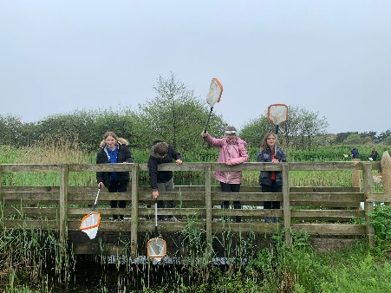
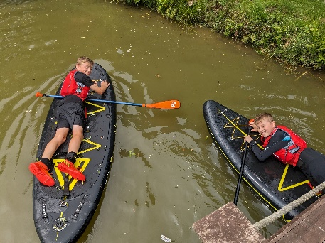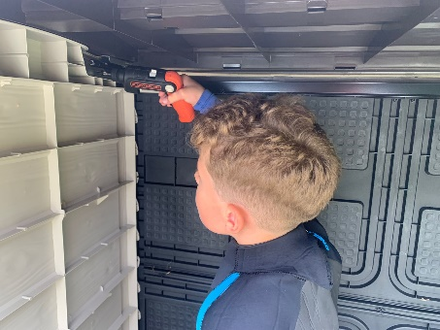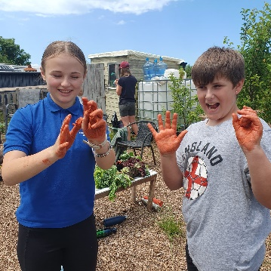
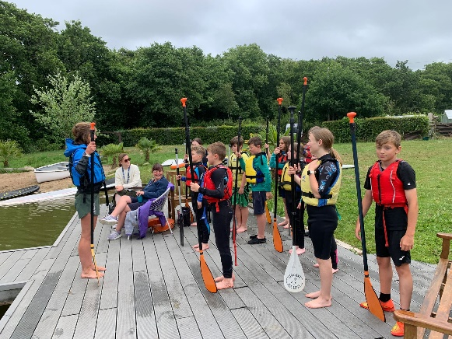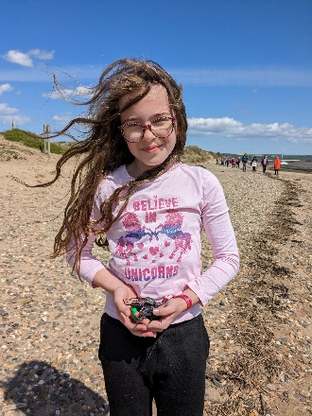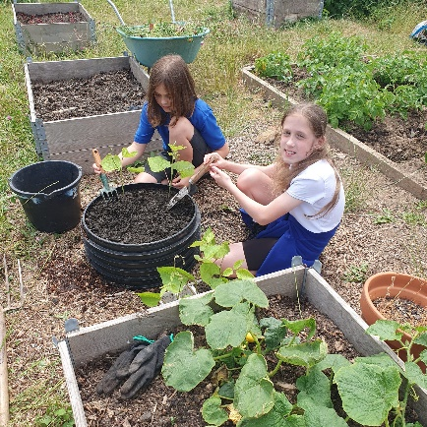
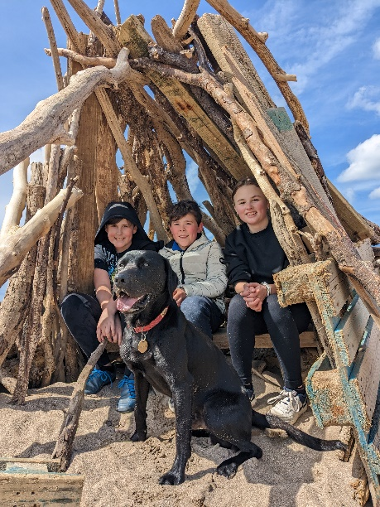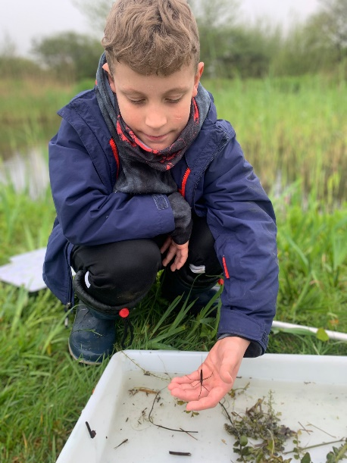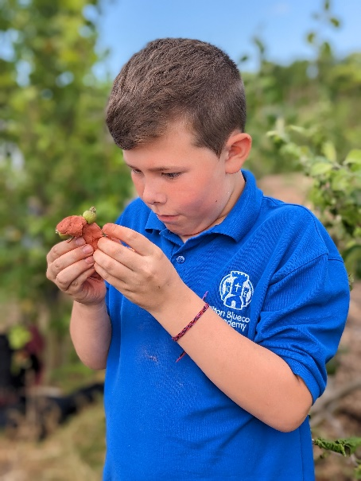
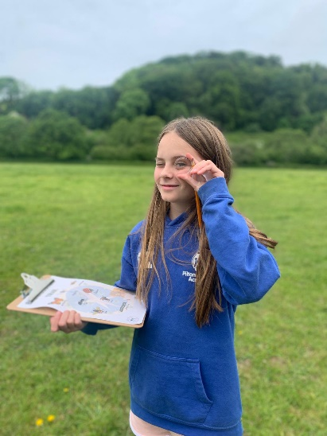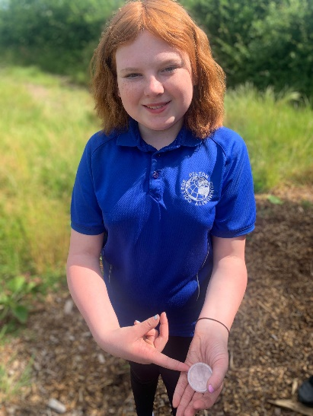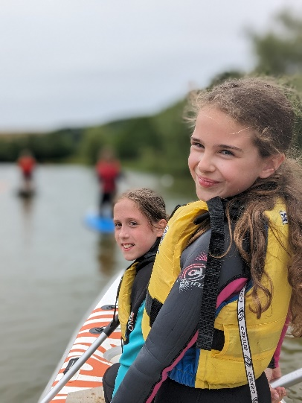
Every term, your students show exemplary manners and behaviour. We are all, always so impressed by them . Thank you also to your staff who are always very helpful and keen to get involved. It makes a big difference, and it definitely shows the ‘family’ feel that Pilton Bluecoat has.

