Instrument Lessons

- At Pilton Bluecoat Academy we have six peripatetic music teachers who offer private instrument lessons; either one to one or in small groups
- Teachers come into school once a week during term time and lessons are during the school day
- Please contact the teacher directly for the cost of lessons and availability
- If your child is interested in learning but doesn’t have an instrument, the teacher may have an instrument that they can borrow or hire – please ask
- If your child receives pupil premium funding, you are entitled to a 50% reduction in the cost of lessons. Please let the instrument teacher know this when you are arranging lessons so that you are charged the correct amount

Keyboard/Piano  Lessons will be taught on a keyboard or piano depending on availability. | 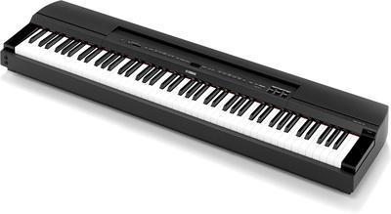 | Rebecca Barrow  07828 601778  rebeccabarrowmusician@gmail.com | Monday or Wednesday
Voice/Singing  Individual or small group lessons available |  | Rhiannon Wright  rhiwright92@gmail.com | Tuesday afternoon
Violin | 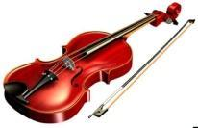 | Rebecca Barrow  07828 601778  rebeccabarrowmusician@gmail.com | Wednesday
Guitar, Ukulele or Bass Guitar  Taught individually or in groups. | 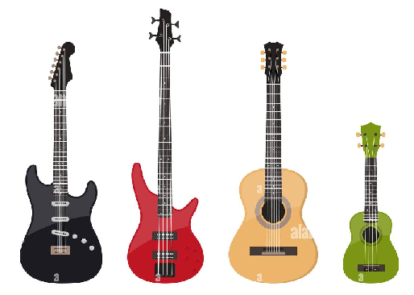 | Ben Sharpe  b.sharpe1988@gmail.com | Wednesday Afternoon
Rock Band  Keyboard, electric guitar, drums, voice. Taught in groups.  ALL INSTRUMENTS ARE PROVIDED BY STUART | 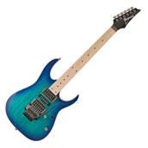  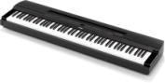  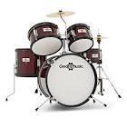 | Stuart Snelling- Rocksteady  https://www.rocksteadymusicschool.com/primary/  0330 113 0330 | Thursday Morning
Drums  Lessons will be taught on an electric drum kit in school. |  | Martin Bradshaw  07974 849303  imsnorthdevon@gmail.com | Thursday
Flute | 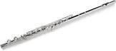 | Susan Northrop  07890 022264  Susan.e.northrop@googlemail.com | Friday Morning
Clarinet | 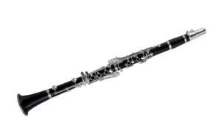 | Susan Northrop  07890 022264  Susan.e.northrop@googlemail.com | Friday Morning
Saxophone | 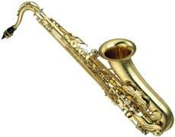 | Susan Northrop  07890 022264  Susan.e.northrop@googlemail.com | Friday Morning

