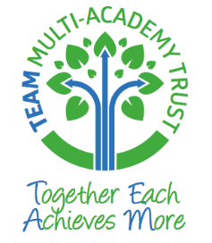

Pilton Bluecoat C of E Primary Academy

Collective Worship and Spiritual Development Policy




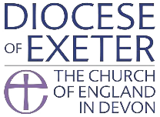




Collective Worship
Life, love and learning to the Full
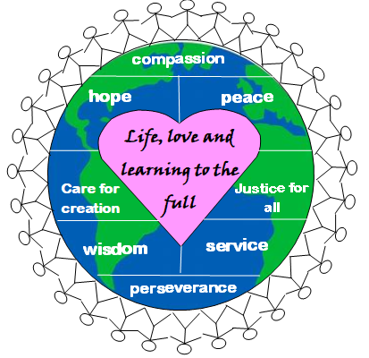
At Pilton Bluecoat Academy, we aim to build the foundations of “life in all its fullness”, underpinned by our Christian values where we understand what it means to be loved and to love others within our school and our local, national and global community.

Our collective worship provides opportunities for children to explore life in all its fullness as part of an inclusive community that celebrates and explores spirituality in accordance with its Christian foundation.
What is Worship?
“It is the essence of worship that is about giving attention to the divine” (SACRE 1989)
Church of England schools are required to hold a daily act of collective worship which is consistent with the faith and practice of the Church of England.
All acts of collective worship (e.g. prayer) are invitational and inclusive for all children regardless of faith or non-faith and will be introduced as such by the adult leading collective worship.
The right of withdrawal
All parents have a legal right to withdraw their child from acts of worship. If there are any children whose parents exercise their right to withdraw them from worship, alternative activities will be provided in consultation with the children’s parents. This does not mean in any way children will be exempt from the Christian ethos of the school which underpins the whole of school life. Parents are made fully aware of this when they enrol their children.
Aims and Objectives
- Enable all children and staff to explore and celebrate the differences and diversity found in the variety of forms of worship in the Anglican Christian tradition, in the UK and beyond.
- Lead the school community to the ‘threshold of worship’ in order for them to make an informed choice about their own involvement and to consider their own personal relationship with God.
- Seek to deepen and widen the experience of those of faith.
- Use celebration, silence, reflection, prayer, song, symbols and imagery as vehicles for worship and spiritual growth.
- Encourage all present to explore their own personal beliefs.
- Raise awareness through reflection of the ultimate questions of life.
- Reaffirm, strengthen and practise school values.
- Celebrate each individual member of the school community.
- Develop a sense of community within the school, the locality (e.g. the local church) and foster the sense of being part of the wider community.
- Foster a concern for the needs of others.
- Consider how we can be courageous advocates in a hurting world.
We aim to provide opportunities for children and adults to:
- Worship God (should they wish to)
- Celebrate all that is good and beautiful and express thankfulness for the joy of being alive.
- Have experiences which are relevant to the age, aptitude and family background of the children.
- Have time for silent reflection and exploration of inner peace.
- Experience a range of worship, including singing, music reflection
- Experience collective worship that takes place in an environment that is conducive to worship.
Worship is invitational and inclusive. We acknowledge that children and adults will be at different stages of spiritual development and that they should feel able to respond and participate at their own level.
Values
Each half term, collective worship will be centred on one of our school values or our school vision. Our school values were chosen by children, governors, staff and parents in collaboration.
To help children understand appreciate what this means, we have eight values that we explore throughout the year in collective worship:
- Compassion
- Serving others
- Justice for all
- Peace
- Hope
- Caring for creation
- Wisdom
- Perseverance (endurance)
We look at the work and message of Jesus Christ throughout the year and we also regularly explore the story of Nehemiah as a picture of the community that we seek to build.
Organisation
Collective worship is an important part of school life and it is expected that all children will normally attend. Collective Worship themes are based around Bible stories linked to the half termly value, songs linked to the half termly value and topical events which link to our school vision and values.
Monday: Led by Head teacher
Tuesday: Led by clergy or lay volunteer from Pilton Church
Wednesday: Led by teacher
Thursday: Visitor or singing worship
Friday: Celebration assembly
- Where appropriate, collective worship will include the open and close, a time for reflection and prayer.
- It will include use of school Trinity prayer and the Lord’s Prayer at least once a week
- Ethos Ambassadors from each year group take an active part in collective worship
- Half termly collective worship timetable with themes and resources to be given to all teaching staff as well as clergy.
- All teachers lead worship at least once a term.
Monitoring, Evaluation and Review
Monitoring of collective worship will be carried out by Head of School, Chair of Governors and Collective Worship Lead. Some monitoring is carried out by Ethos Ambassadors.
Feedback will be given to staff and ethos committee.
Inclusion and equal opportunities
A daily act of worship is held for all children regardless of their background or religion. Every effort is made by the school to involve all children unless withdrawn by their parents. All acts of collective worship are introduced as invitational by all adults leading collective worship.

SPIRITUAL DEVELOPMENT
I can talk about myself, others, the world and beyond.
Diocese of Norwich document on SMSC: A Christian perspective, states:
Pupils’ spiritual development is shown by their:
- Ability to be reflective about their own belief, religious or otherwise, that inform their perspectives on life and their interest in and respect for different people’s faiths, feelings and values.
- Sense of enjoyment and fascination in learning about themselves, others and the world around them.
- Use of imagination and creativity in their learning.
- Willingness to reflect on their experiences.
Rebecca Nye’s work on spirituality with primary aged children recommends providing opportunities for children to experience space, process, imagination, relationship, intimacy and trust. These can be found within collective worship as well as throughout the curriculum and in being a member of a community that loves to the full.
There are so many ways that the curriculum promotes spiritual development. Some examples (though not exhaustive) include:
Subject | Contributes to spiritual development by…
PE | - delighting in spontaneity, allowing children to express themselves creatively (eg through dance)  - Allowing a sense of connection with one’s own body.  - Promoting awareness of reliance on each other and sense of belonging to a community (team)  - Developing self-awareness about strengths and limitations-
Computing | - Developing sense of idea  - Use of internet to explore big questions and research opportunities for courageous advocacy
Drama | - Allows for self-expression and insight, chance to understand ourselves and others better.
Design and technology | - Developing sense of own capability and chance to explore different ideas.  - Considering the preciousness of a created work and linking it to better understanding of stewardship.  - Exploring and celebrating personal creativity
Music | - Opportunities to express pleasure and joy, and to feel “inside” the music.  - Growing understanding of how music can affect mood, allow for reflection or express a variety of emotions.  - opportunities for self-expression and creativity.
Art and Design | - Children can explore natural phenomena and spirituality through arts.  - Exploring meaning and inspiration behind works of art  - Considering how colour can express or provoke a feeling or mood.  - Giving an opportunity to express big ideas.
RE | - experiencing awe and wonder through learning about and from stories, celebrations, rituals and different expression of religion and worldview.  - Gaining a sense of shared humanity through contact with people from different backgrounds  - by asking and responding to questions of meaning and purpose.  - Considering questions about God and evaluating truth claims  - By exploring spiritual practices such as worship and prayer and considering the impact of these on believers as well as the relevance to their own life.
PSHE | - By developing awareness of and responding to others’ needs and want  - By exploring meaning and purpose for individuals and society  - By developing resilience and inner strength
Geography/ global links | - By appreciating the beauty of Earth and gaining and understanding of our place in it.  - By considering one’s own impact on the world.  - By comparing own lives to those of children around the world
History | - By appreciating sacrifices made by people in the past  - By thinking about how history has been made by large events but also by ordinary people- and how their own choices contribute to the future.
Forest schools | - Gaining a sense of awe and wonder at the natural environment.  - Growing awareness of fragility of life and our responsibilities towards it.  - Understanding of how we are connected to our natural environment.
MFL | - By exploring the beauty of languages from around the world, how they are constructed, how they sound.  - How one’s language is fundamental to one’s identity.  - Developing an appreciation of diversity.
Literacy | - Opportunities to express oneself creatively through language.  - identifying with others through reading, using inferences to understanding motivation and emotion.  - Develop imagination through story.
Science | - demonstrating openness to the fact that some questions cannot be answered by Science.  - Opportunities for pupils to ask questions about how living things rely on and contribute to their environment.  - Experiencing awe and wonder at the order of physical processes such as forces, light or electricity.  - Becoming aware of our place in the universe and how our lives fit in to the aeons describe during studies on fossils or when studying space.
Maths | - By making connections between numeracy skills and real life.  - Considering infinity.  - By considering pattern, order, symmetry and scale both man made and in the natural world.

